Pesticides in Forestry

Canadian Forests and Forestry – Global and National Importance
Canadian forests constitute 10% of the total forested land mass of planet earth [1] and are thus a key element in global carbon and other biogeochemical cycles. Our forests provide habitat for an estimated 140,000 species of plants, animals and microorganisms (excluding viruses) [2]. As of May 2000, 353 wildlife species in Canada are listed as being at risk. Of these, a total of 85 species -as different as the tailed frog and the woodland caribou - are considered forest dependent [2].

In economic terms, Canada controls a 15 to 30% share of world-wide lumber, pulp and paper commodities and ranks first in net value of exported forest products [3]. In 1999, the total value of Canadian forest products exports reached an all time high of 44.2 billion dollars [4]. From an employment perspective, it is estimated that logging and forestry account directly for 384,000 jobs and indirectly for 493,000 jobs [2]. Many smaller communities in Canada are solely dependent on forestry. Thus from any perspective, global or national, environmental or economic, the Canadian forest resource and its derivative industries are critically important.

The vastness of Canada’s forests is one of the unique features distinguishing our nation. Forests cover approximately 42% of the Canadian landscape (Fig 1.) and fully 80% of the area south of the arctic tree line. Several different forest regions are recognized in Canada with the vast boreal forest region dominating. The majority (68%) of Canadian forests are softwoods (conifers) with much smaller proportions of the forest landmass comprised of mixedwoods (18%) or hardwoods (15%).

Unlike many other forest-producing nations, the vast majority (94%) of Canadian forests are publicly owned [1]. Under our constitution, these lands are managed on behalf of the public largely by provincial and territorial governments with a focus on optimizing economic, environmental, aesthetic, and spiritual values associated with the resource. Given that each province and territory has unique laws and policies, forest management in Canada is a complex and dynamic mixture of policy, politics, emotion and science.

In 1995, approximately 7.6% (roughly 32 million hectares) of Canada's forest land was protected by legislation.. Since that time, many provinces have increased their number of protected areas. For example, through the Ontario Living Legacy program, the province of Ontario has recently created 378 new parks and protected areas, enhancing previously protected areas by more than 2.4 million hectares. In total, Ontario’s protected areas account for 10% of the land mass and cover an area equal to that of Nova Scotia and Vancouver Island combined. On a national scale, only a small portion (0.4%) of the total 235 million hectares of forests considered commercially productive are actually allocated for harvest on annual basis. The utilization rate or Annual Allowable Cut (AAC) approximates 1 million ha annually and has been relatively stable about this level for several years

Figure 1. The Forest Regions of Canada (Reproduced from [2]).

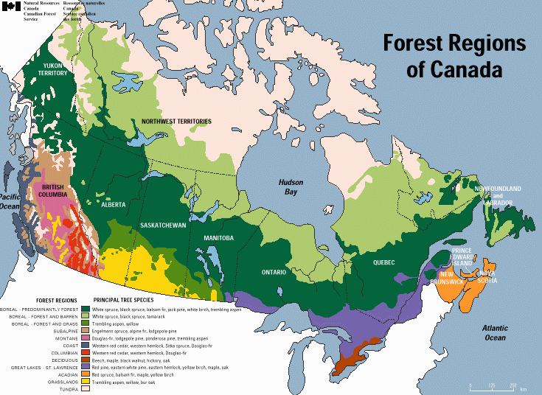

Figure 2. Breakdown of the Canadian Forest Resource (Reproduced from [2])
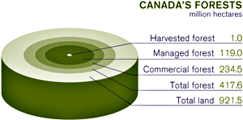

Factors Depleting the Forest Resource and Management Techniques
A variety of factors, both natural and anthropogenic may work alone or interactively to deplete both the economic and ecological value of the Canadian forest resource. Key depletion factors include fire, insects, disease, harvesting, understocking, competing vegetation and altered land use. While many of these may be considered as natural elements of forest ecosystems, they all represent significant factors resulting in depletion of the forest resource in terms of its ecological function, biodiversity, aesthetic and derivative economic value. For comparative purposes, the total forested land area lost to these factors over the three year period 1995-1997 is shown in Table 1.

Table 1. Comparative Forested Area Lost to Various Depletion Factors (1995-1997)
Millions of Hectares
Depletion Factor | 1995 | 1996 | 1997
Fire | 7.10 | 1.75 | 0.62
Insectsª | 12.82 | 7.12 | 3.96
Harvesting | 1.02 | 1.04 | 1.03
Under-stocking^{b} | 2.25 | 2.10 | 2.10
Disease | NA | NA | NA
Altered Land Use | NA | NA | NA
ª Areas classified as moderately to severely defoliated by major insect species
^{b} Data graphically interpolated from REGEN component of the National Forest Database Program.

Fire - While linked to climate and therefore highly episodic, wildfires and fires resulting from human activity are often major factors depleting the Canadian forest resource. In 1999 fires across the country burned more than 1.7 million ha, almost double the area harvested annually. At larger spatial scales fire exclusion is practically impossible, economically infeasible as well as ecologically undesirable. Wildfires are a natural disturbance and in some forest ecosystems such as the boreal region, are key drivers of succession cycles. For example, even as fire kills a mature stand of jack pine, it also opens the seed cones, allowing the species to reproduce and survive. Therefore, fire management policies attempt to balance suppression costs with values at risk, while recognizing the natural role of fire in managing the landscape.

Insects – Similarly, native insects are also natural components of forest ecosystems and succession cycles. However periodic outbreaks of exceedingly high population may significantly deplete the resource directly or predispose forested areas to fire. Thus, insects may directly or indirectly alter forest biodiversity, significantly limit the economic use of certain tree species and/or render areas of forests unsuitable for recreation, wildlife habitat, or other uses. Important insect pests in Canada include spruce and jack pine budworms (Choristoneura fumiferana, C. occidentalis, and C. pinus pinus), forest tent caterpillar (Malacosoma disstria), eastern hemlock looper (Lambdina fiscellaria fiscellaria), tussock moths (Orgyia spp.), mountain pine beetle (Dendroctonus ponderosae) and gypsy moth (Lymantria dispar).

Insect damage reports often list areas where there is mortality or moderate to severe defoliation of trees. Significant growth losses are generally deemed to begin when crown defoliation reaches 40%, whereas successive years of defoliation may be required to induce tree mortality. The type and degree of damage and resultant depletion of the forest resource varies with insect and tree species, site type, climatic conditions and a multitude of other factors. Figure 3 shows moderate to severe defoliation by several key insect pests and emphasizes the highly sporadic or cyclical nature of infestations. For the years 1990 to 1998, the total area moderately to severely defoliated by insect pests exceeded the total area harvested by several fold each year. Currently, an estimated 5.1 million ha of forest land are moderately to severely defoliated by insect pests nationally. Even a moderate level of control exerted on defoliating insects has the potential to substantially enhance forest sustainability.

Fig. 3. Area of Forest Depletion by Major Insect Species (1975-1998)
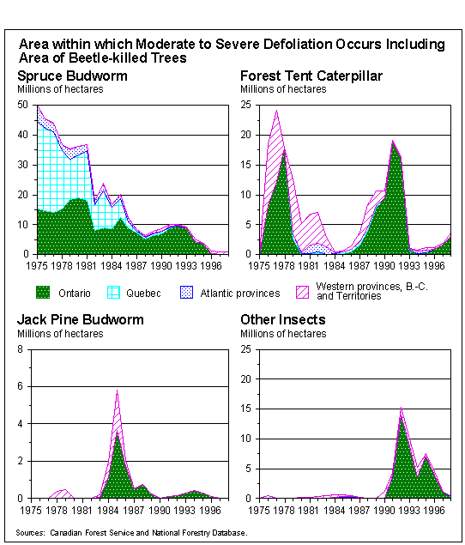

Harvesting - The national harvesting rate for the Canadian forest resource has been relatively stable at approximately 1 million ha annually since 1994. Owing to the even-aged nature of many stand types and economic considerations, clearcutting is the predomiant method of harvest. For example in 1997, ~ 87% of the harvest was by clearcut, while a small ~ 11% percentage of the landbase was harvested by selection cutting techniques. While clearcutting will likely remain predominant in Canada for the foreseeable future, harvesting techniques are changing. In Ontario, for example, increasing use is made of "careful logging around advanced growth." In Quebec, "cutting with protection of regeneration and soils" was mandated by the new Forest Act. In British Columbia, a recent corporate decision was taken by industry giant Weyerhauser to eliminate the practice of clearcutting on their lands.

Under-stocking - As in many other countries, the history of Canadian forestry included a significant period of exploitation. Harvesting without sufficient regeneration of the resource led to a substantial backlog of understocked sites. Fully 16% (2.5 million ha) of harvested crown lands in Canada are currently considered understocked (i.e. will require silvicultural treatment and do not currently contain enough young trees to meet a provincial or territorial standards). Figure 4 demonstrates a continuous gap between area harvested and area successfully regenerated on an annual basis over a period of more than 20 years.

Fig. 4. Regeneration of Crown Lands in Canada, 1975-1997.
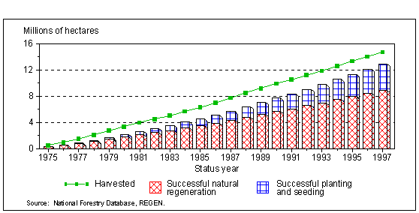
While the status of forest regeneration of harvested lands has generally improved between 1975 and 1992, the cumulative debt in understocked forest lands is substantial. The effect is analogous to national deficit/debt scenarios where large annual deficits are no longer the norm but a legacy of substantial long-term debt remains. Reversing this trend and eliminating the annual regeneration deficits as well as the historical understocking debt are critical to sustainable forest management.

Competing Vegetation – In a manner analogous to home-gardens or agricultural scenarios, disturbed forest sites are subject to invasion by pioneering “weedy” species which may inhibit crop growth or kill trees outright through competition for light, moisture, nutrients or physical space. Competing vegetation represents a major mechanism by which native forests have been depleted or altered in relation to their original composition. Competing vegetation has been estimated to reduce the growth of regenerating forests, with volume losses ranging from 40 to 100%. Principal competitive species in Canadian forests include red raspberry (Rubus ideaus), speckled alder (Alnus rubra), trembling aspen (Populus tremuloides), reed canary grass (Calamagrostis canadensis), red maple (Acer rubrum), pin cherry Prunus pennsylvanica, and fireweed Epilobium angustifolium, as well as regionally important species such as salal (Gaultheria shallon), Kalmia (Kalmia angustifolia), thimbleberry (Rubus parviflorus) and salmonberry (Rubus spectabilis).

Disease - Forest diseases are often expressed by the abnormal growth or development of
trees and include a variety of disorders that reduce growth, lower wood quality, cause predisposition to attack by other agents, or culminate in the death of the trees. Infectious diseases are caused by living agents such as fungi, bacteria, viruses, and higher plants, which attack trees to obtain nutrients essential to their development. Infectious forest diseases are classified as native or introduced. Native diseases do not usually threaten the existence of a tree species, but may cause severe losses in some stands. Major diseases affecting or depleting Canadian the forest resource or value of its products include white pine blister rust (Cronartium ribicola), hypoxolon canker (Hypoxylon mammatum), dutch elm disease, annosus root rots (Heterobasidion annosum), armillaria root diseases (Armillaria spp.). Introduced diseases, such as white pine blister rust, may become epidemic and threaten the existence of a susceptible tree species throughout its entire range. The combined potential for blister rust and weevil infestation often obliterate foresters attempts to appropriately regenerate white pine sites throughout Canada. Many diseases are opportunistic, infecting trees that have been stressed or damaged by other mechanisms. For example, Dutch elm disease is again spreading fast across Eastern Ontario, likely as a result of the 1998 ice storm which resulted in many broken and damaged trees attracting beetles that vector the disease.

Altered Land Use
Changing land-use patterns associated with road-building, mining, and urban sprawl, deplete forests at an estimated rate of 270,000 ha per year. Often changes in land use occur on highly productive forest sites and effects are largely irreversible.

Forest Use Pesticides and Their Role in Integrated Pest Management
Forest management in Canada covers a spectrum ranging from extensive through basic to intensive with varying degrees of human intervention, financial investment and scientific basis (Fig. 5).

Figure 5. Spectrum of Forest Management in Canada
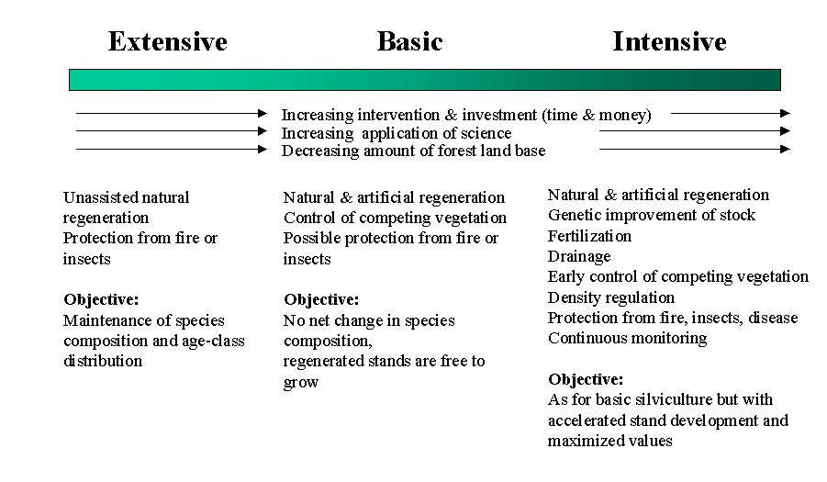

The intensity of management applied to a given site is often dictated by the inherent quality or ecological value of the site or the economic value of the stand occupying the site as well as corporate or political policies. Historically, forest management in Canada was largely extensive and exploitive in nature. As the resource dwindles and quality supply becomes an increasingly important issue, management strategies are beginning to evolve to include proportionally more intensive efforts. Over larger spatial scales, there is no doubt that all degrees of forest management will continue and that intensive efforts will be primarily focused on those sites with highest quality, potential and fewest economic constraints.

Integrated pest management (IPM) may be defined as the combined use of chemical, biological, cultural and genetic methods for effective and economical pest control with a minimum effect on non-target organisms and the environment. At the landscape level and even within a given site, foresters employ a variety of these constituent techniques to control or limit depletion by insects, disease and competing vegetation factors. As an example, through a rotation period of approximately 50 to 80 years in white spruce, a typical management approach might involve:

- modified harvesting techniques to mitigate against competing vegetation, insects or diseases,
- mechanical techniques to prepare the site for planting and inhibit development of competing vegetation
- herbicide application to enhance regeneration success and maximize growth,
- silvicultural treatments such as thinning to enhance volume production, quality and health of the stand (thereby reducing the risk of insect or disease infestation)
- application of a biological insecticide, such as Btk, to control defoliating insects such as spruce budworm

Within the context of integrated pest management in Canadian forestry, pesticides play a crucial role particularly in control of insect pests such as spruce budworm and hemlock looper and for control of competing graminaceous, herbaceous or woody vegetation. While all pest control products used in Canada must be registered under the federal Pest Control Products Act, it is provincial decisions that control where and how such products will be used in forest management. Interestingly, pest control products used in forest management account for only about 2% of the total pesticide sales in Canada. However, public opposition (see for example [5]) to such uses has always been and remains intense leading some provinces (e.g. Ontario) to invoke forest management policies which avoid the use of synthetic chemical insecticides and others (e.g. Quebec) to propose future bans on the use of chemical herbicides in forestry.

Insecticides – Historically, insect pest control programs in Canadian forestry were focused almost entirely on spruce budworm and involved aerial applications of broadspectrum insecticides such as DDT. During the 1950s and 1960s, vast areas of eastern Canadian forests (e.g. in 1960 1.2 million ha), received aerial applications of DDT for budworm control. The majority of applications were made in New Brunswick and Quebec at rates ranging from 0.27 to 0.55 kg a.i. per ha. Subsequent to 1968 when the use of DDT was discontinued, a variety of other products such as phosphamidon, matacil and fenitrothion were used for budworm control. Owing largely to risks associated with non-target effects on various species of fish and birds, use of these products was discontinued and substantial research efforts were undertaken to discover and develop more environmentally acceptable approaches and products. The development and subsequent widespread operational use of Bacillus thuringiensis var. kurstaki (Btk) in Canadian forestry represents a major success in the history of biological control of insects in Canada. Continued efforts have focused on research and development of several insect specific viruses, as well as novel narrow spectrum and biorational chemicals such as tebufenozide and azadirachtin.

The principal insecticides currently used in Canadian forest insect pest management are summarized in Table 2.

Table 2. Insecticides Used In Canadian Forest Pest Management

Common Name | Trade Name Examples | Manufacturer | Type | MLRª | Mode of  Action
Btk | FORAY, DIPEL, THURICIDE | Sumitomo  Thermo Trilogy | Biological | 2 x 30 | gut membrane  disruption
Tebufenozide | MIMIC | Rohm & Haas | Benzoic Acid | 2 x 70 | ecdysone agonist
Fenitrothion^{b} | Sumithion | Sumitomo | Organo-phosphate | 2 x 210 | acetylcholine esterase inhibitor
Azadirachtin^{c} | NEEMIX | Thermo Trilogy | Botanical | 2 x 35 | prothoracicotropic  hormone blocker

ª MLR = maximum label rate expressed in grams of active ingredient per hectare, except for Btk where MLR is expressed in billions of international units (BIU) per hectare
^{b} Fenitrothion use was discontinued in 1993
^{c} Azadirachtin received a temporary registration in 2000 for control of sawfly species

Figure 6 shows historical and geographic use patterns broken down by product and province respectively.

Fig. 6. Insecticide Use in Canadian Forestry by Product, Province and Year

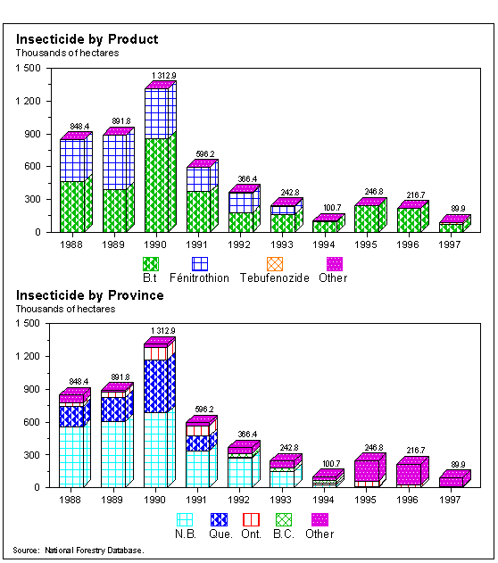

The graphic clearly demonstrates that total insecticide use varies dramatically in correlation to cyclic population levels of major pest species, particularly spruce budworm. Thus, over the recent 10 year time period, total insecticide use was maximal in 1990 in response to the last major outbreak of spruce budworm. A substantial decline in total pesticide applications has occurred since that time as populations of this dominant approached a low ebb in the cycle. Bacillus thuringiensis var. kurstaki (Btk), a biological control product produced via fermentation, has been the principal insecticide used in Canadian forestry over the past 12 years, with use primarily for control of spruce budworm, jackpine budworm and eastern hemlock looper. A regulatory review of fenitrothion use in forestry was undertaken in the early 1990s [6], and since 1993 use of this product has essentially been discontinued. A subsequent regulatory decision was to officially terminate the broadscale aerial application uses of fenitrothion on spruce budworm and hemlock looper after 1998. Thus, Bt and tebufenozide have been essentially the only insecticides used for spruce budworm control in recent years. The majority of these applications continue to be made in the eastern provinces, particularly New Brunswick, Quebec, Ontario and Manitoba, where spruce budworm attacks high value spruce/fir stands. Applications are made entirely by fixed-wing or rotary-wing aircraft. Small amounts of MSMA and carbaryl, which constitute other insecticides in use through this time-period, were applied by ground in the province of British Columbia for control of mountain pine beetle and spruce budworm respectively.

Herbicides - In Canada, owing largely to difficult access, remoteness of sites, and inherent cost-effectiveness relative to other alternatives, herbicides remain the principal mechanism for controlling competing vegetation. However, in contrast to the United States, and many other major timber producing countries, only a few herbicides are registered for broadcast application in Canada (Table 3).

Table 3. Principal Herbicides Used in Canadian Forest Management
Common Name | Trade Name Examples | Manufacturer | Type | MLRª | Mode of  Action
Glyphosate | VISION | Monsanto | Organophosphate | 2.24 | IAA
2,4-D | ESTERON | DowAgroSciences | Phenoxy acid | 5.10 | AM
Triclopyr | RELEASE | DowAgroSciences | Pyridine | 3.84 | AM
Hexazinone | VELPAR L | DuPont | Triazine | 4.00 | PSII
Simazine | CLEANCROP | Ciba-Geigy | Triazine | 6.70 | PSII
Picloram | TORDON | DowAgroSciences | Pyridine | 1.43 | AM

ª MLR = maximum label rate expressed in kilograms of active ingredient per hectare,
^{b} Where: IAA = inhibition of aromatic amino acid synthesis, AM= auxin mimic & disruption of RNA/DNA and protein synthesis and PSII = photosystem II inhibition

Herbicides may be applied either to prepare the site prior to planting (chemical site preparation), or to control competing vegetation after planting (release). In Canada, site preparation is largely conducted using mechanical methods and thus chemical site preparation represents a relatively small proportion of overall forest herbicide use. Figure 7, demonstrates herbicide products and their geographic use patterns over the period 1988 to 1997.

Fig. 7. Herbicide Use in Canadian Forestry by Product, Province and Year
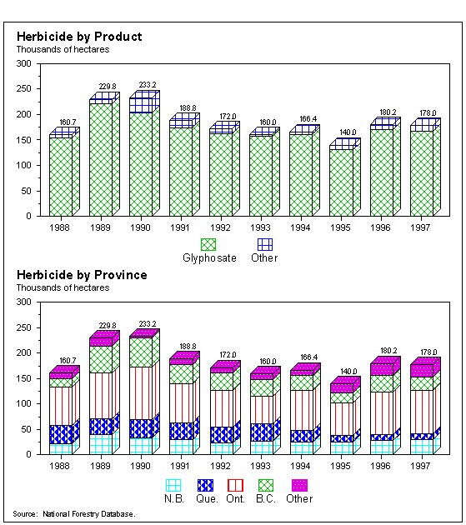

Through this period, use rates were relatively constant at about 200,000 ha per year, equivalent to approximately 20% of the harvested area or roughly 40% of the landmass being artificially regenerated in latter years. Glyphosate, marketed in forestry under the tradename VISION (chemically identical to ROUNDUP as used extensively in agriculture) continuously accounts for well over 80% of the forest herbicide-use market nationally. While regionally variable, glyphosate is predominantly aerially applied for release of high value conifers (jack pine, black spruce, white spruce) from competing vegetation. Relatively small areas (4 to 5 thousand ha annually) receive applications of 2,4-D, almost all by aerial means and for release of lowland black spruce in Ontario. In contrast, triclopyr use patterns (~ 3.5 to 5 thousand ha annually) involve both aerial (principally in Ontario) and ground (principally in British Columbia) applications for conifer release from tolerant hardwoods. Other registered herbicides (hexazinone, simazine, picloram) receive exceedingly limited use (each ~ 500 ha or less annually) primarily for chemical site preparation.
Fungicides - Most diseases in Canadian forestry are controlled through appropriate silvicultural or stand management techniques. For example, control of annosus root root is often achieved by shortening rotations and mitigating against wounding of trees during harvest operations. For control of armillaria root diseases, two management strategies include reducing the amount of inoculum by removing stumps or regenerating the site with one or more resistant or poor-host species. A Dutch Elm disease program is carried out in many provinces of Canada with focus on high value trees in urban settings. Integrated approaches including sanitation pruning and diseased tree removal, basal spraying with chlorpyrifos to control the elm bark beetle vector, replacement planting are all components of the program. Operationally, very few fungicides are used for disease control in forestry. The treatment of stump surfaces with borax has been used to in an attempt to prevent spore infection by Heterobasidion annosum, the causal agent of annosus root rots.

Looking to the Future
Management forest resources in general, and forest pest in particular, will remain complex, dynamic and challenging. Nonetheless, a few fundamental concepts are expected to endure and become more prevalent in future Canadian forest resource management, these include:
- sustainable development
- management for multiple values
- management to protect ecological function and integrity
- protection of sensitive, unique or high value sites
- integrated pest management

Evolution of forest pest management is also expected to continue with an emphasis on increased integration, minimal environmental impact and development of early intervention as opposed to “crisis” pest management. Within this context, control of invasive, exotic pest species which potential for substantial ecological or economic damage, including institution of non-tariff trade barriers, is likely to become increasingly important. Recent examples of this trend include introductions of exotic insects such as Asian gypsy moth (Lymnatria dispar), brown spruce longhorn beetle (Tetropium fuscum), Asian longhorn beetle (Anoplophora glabripennis). Some exotic plants, such as Scotch broom (Cytisus scoparius L)., a perennial, leguminous weed also have extreme invasive potential for massive. Targeted research, monitoring and control programs are already developing for all of these exotic species.

Globalization of supply and trade in forest products, coupled with generally enhanced awareness of global environmental issues, will likely accelerate current trends toward international certification, inclusive of assurance of environmentally sustainable harvesting, silviculture and pest management practices. Toward this end, increased emphasis on development and operational use of preventative silvicultural strategies as well as biorational and biological control pest control products will likely continue in Canada, together with expert decision support systems designed to enhance conversion of scientific knowledge into operational practice. Examples of such systems and knowledge exist [7, 8] but still need to be incorporated more widely into operational practice.

New biorational compounds with potential for use in forest insect pest management include azadirachtin and spinosyns. Research and development of azadirachtin accelerated dramatically in the last few years owing to outbreaks of the yellow-headed spruce sawfly (Pikonema alaskensis) in black and Norway spruce plantations of New Brunswick, Nova Scotia and Newfoundland, as well as pine false webworm (Acantholyda erythrocephala) in red, white and Scots pine plantations throughout Ontario. As a result temporary registration for aerial applications of NEEMIX 4.5 was granted for these uses in 1999. Spinosyns are a relatively new group of natural macrolide compounds isolated from the actinomycete Saccharopolyspora spinosa (Thompson et al. 1996). To date, environmental fate and efficacy testing of spinosyns pertinent to Canadian forestry demonstrates signficant potential for registration and use against key forest insect pests including spruce budworm (C. fumiferana). Finally, early research focused slow-release tablets containing fertilizer, fungicide and insecticide, which are applied during planting of white pine is providing encouraging results. Ultimately, such a technique, in combination with breeding for resistance and altered silvicutlural practice may lead to development of highly integrated and early intervention approach overcoming longstanding problems of blister rust and weevil infestations which largely prevent successful regeneration of white pine.

In vegetation management, focused research programs have recently led to a registration submission and potential commercialization of the fungus Chondrostereum purpureum (ECOCLEAR) as the first biologocal control agent for use in Canadian forestry. On the other hand, investigations on bialaphos, a novel biorational compound derived from the soil actinomycete Streptomyces viridochromogenes, have demonstrated significant environmental concerns and a general lack of crop tolerance constraining potential future development of this compound. Silvicultural strategies focused on altered harvesting strategies as a preventative mechanism and increased use of site preparation techniques are also being investigated and show substantial potential.

In a general context, we may expect to see continued evolution toward more co-operative and holistic forest management with a clear ecosystem-level focus. A greater appreciation of the dynamic nature, multiple values and large spatial scales that characterize our forests should develop. Enhanced application of ecological theory [e.g. 9, 10] in Canadian forest management is anticipated. Consistent with such theory, increased focus on sustainable management and protection of ecosystem function and biodiversity as intrinsic values is likely. Increased emphasis on management for multiple values at larger spatial scales necessitates and allows for intensive silviculture and pest management on selected high quality sites where the primary focus is economic benefit. As an indirect benefit, intensive management on selected smaller portions of the landbase should result in concomitant reduction of human intervention on the broader forest landscape. The Living Legacy program recently introduced in Ontario stands as an example of such new co-operative, holistic, large-scale approaches to forest management.

References
- Government of Canada. 1999. Action plans of the federal government in response to the National Forest Strategy (1998-2003) - Sustainable Forests: A Canadian Commitment.

2. State of Canada’s Forests Report. 1999-2000. Forests in the new millenium. http://www.nrcan.gc.ca:80/cfs/pub/pub_e.html).

3. National Forestry Database Program. 1999. Canadian Council of Forest Ministers. http://nfdp.ccfm.org/

4. Statistics Canada's Internet Site. 2000. www.statcan.ca. Data extracted 08/2000.

5. Wagner, R.G., J. Flynn and R. Gregor. 1998. Public perceptions of risk and acceptability of forest vegetation management alternatives in Ontario. For Chron. 74:720-727.

6. Agriculture Canada. 1993. Discussion document. Registration status of fenitrothion insecticide. Plant Industry Directorate D93-01. April 2, 1993. pp. 26.

7. MacLean, D. A. and Porter, K.B. 1995. A DSS for budworm and forest management planning: maximizing protection benefits and forecasting inventiories. In: Proceedings, Decision Support 2001, 12-16 Sept. 1994. Toronto, Ontario. Edited by J.M. Power, M. Strome and T.C. Daniel. American Society for Photgrammetry and Remote Sensing, Bethesda, Md. pp. 530-540.

8. Wagner, R.G., G.H. Mohammed and T.L. Noland. 1999. Critical period of interspecific competition for northern conifers associated with herbaceous vegetation. Can. J. For. Res. 29:890-897.

- Binkely, C.S. 1997. Preserving nature through intensive plantation forestry: The case for forest land allocation with illustrations from British Columbia. Forestry Chronicle. 73:553-559.

- Oliver, C.D. 1999. The future of the forest management industry: Highly mechanized plantations and reserves or a knowledge-intensive integrated approach? Forestry Chronicle 75:229-245.

